**Lab 1: Reverse bias p-n Junction**

**Subject: Semiconductor Devices**



**Name: Ahmed Sabry Hamza Eldeeb**

**ID: 19015258**

**Department: Communications**

**Section: 1**

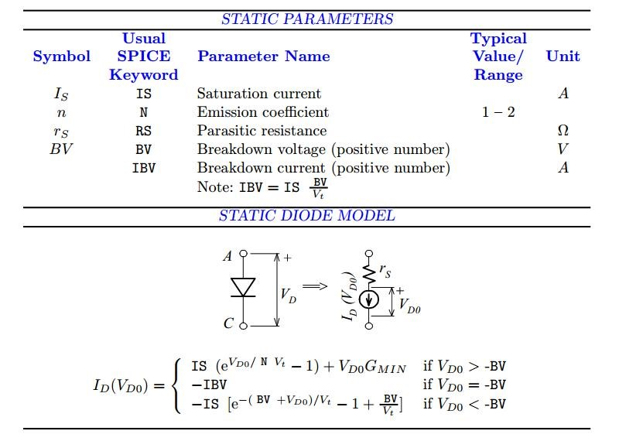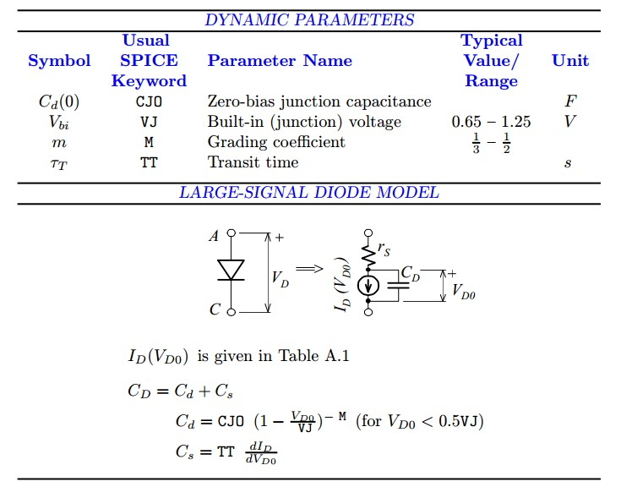

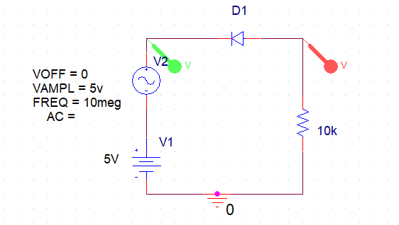1- First circuit, output is resistance (Transient Analysis)

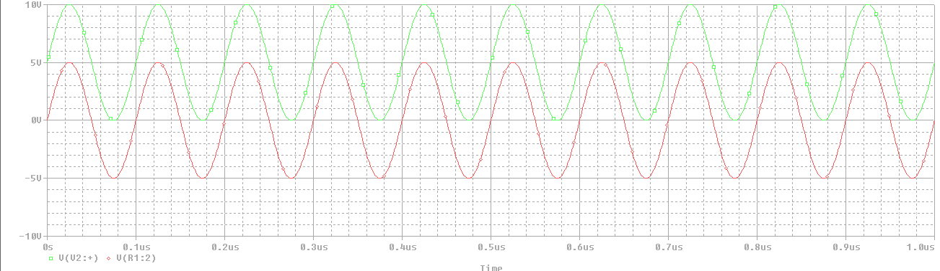Output (Cjo = 15nF)

Comment:

We could see from the previous plot that the input voltage is normal as it is, but what is unexpected that the output voltage (VR) is taking the whole 5V AC voltage which happened due to the high frequency of the AC source (10 MHz).  
Let’s edit the parameter of Cjo of diode to see the difference.

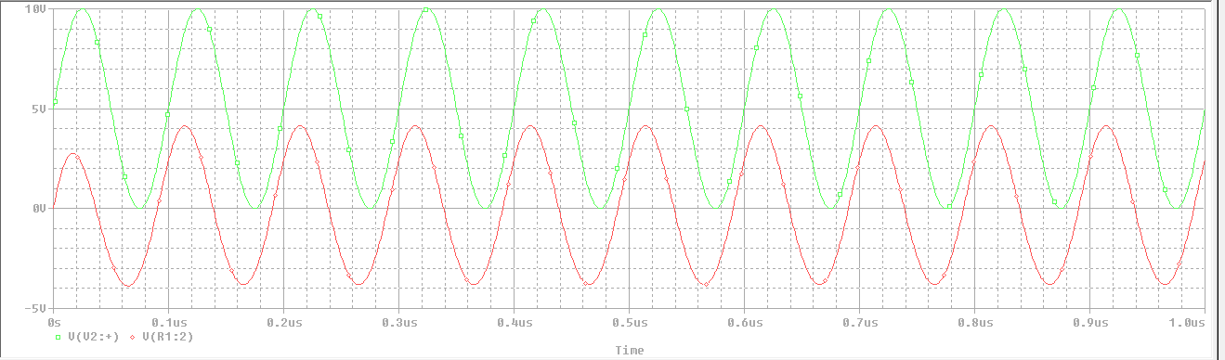Output (Cjo = 5pF)

*Notice that the VR of the output decreased in terms of the amplitude.*

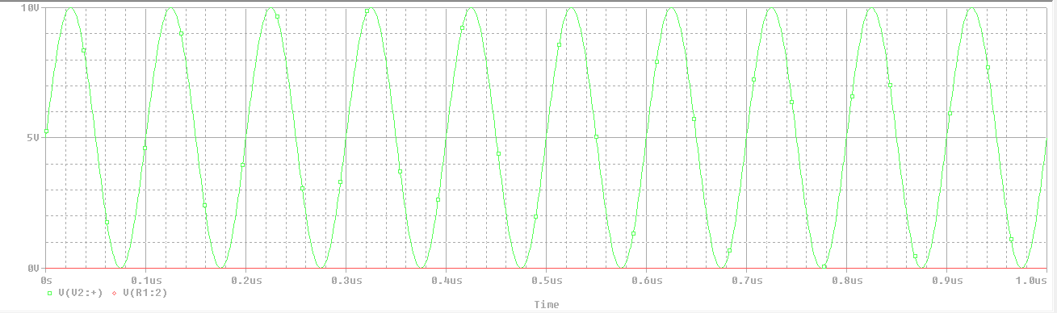Output (Cjo = 1e-20F)

Comment:

Now, we could say that the more you increase the Cjo of the diode, the more it behaves as an open circuit and therefore no voltage will form over the output.  
 *Note that the frequency is fixed in this observation which means that we make the high   
 voltage is looked at as a low one.*

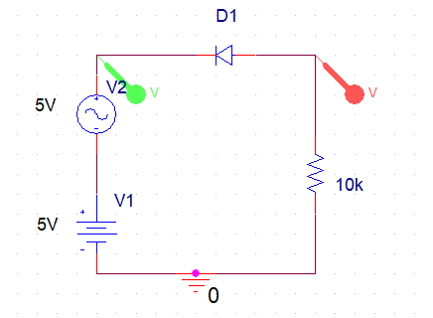1- First circuit (AC sweep) – note that we replaced the sine wave source by AC source

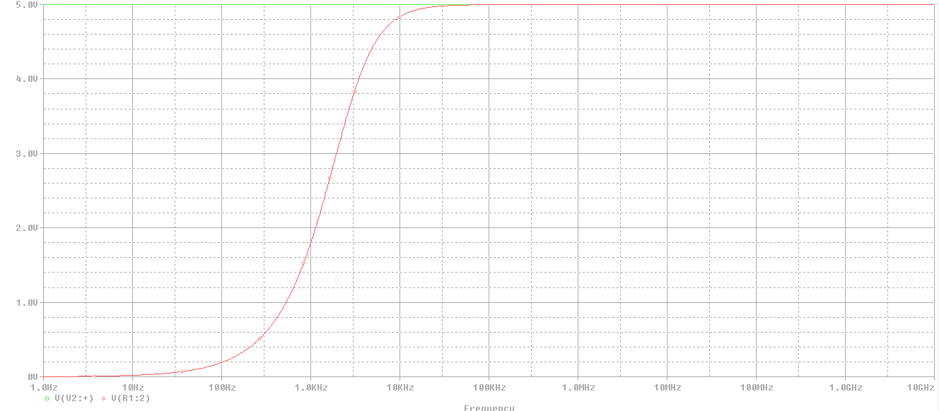Output (Cjo = 15nF)

*Range of appearance of capacitance is 500Hz to 100Khz*

Comment:

Here, the AC sweep plot tells us that internal capacitance starts to appear after roughly 500 Hz of the input AC source to form an output voltage over the resistance. It saturates when the frequency equals to 100 KHz.  
Our circuit acts as High pass filter.

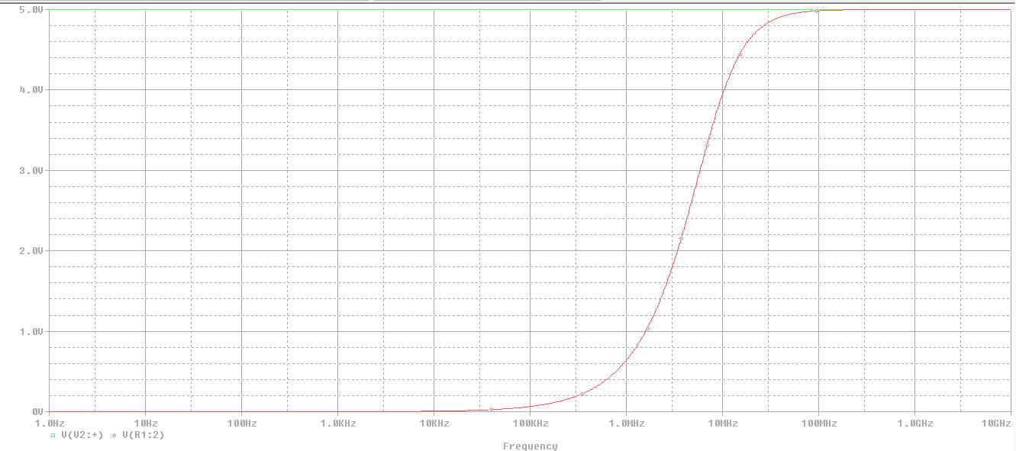Output (Cjo = 5pF)

*Range of appearance of capacitance is 500KHz to 100Mhz.*

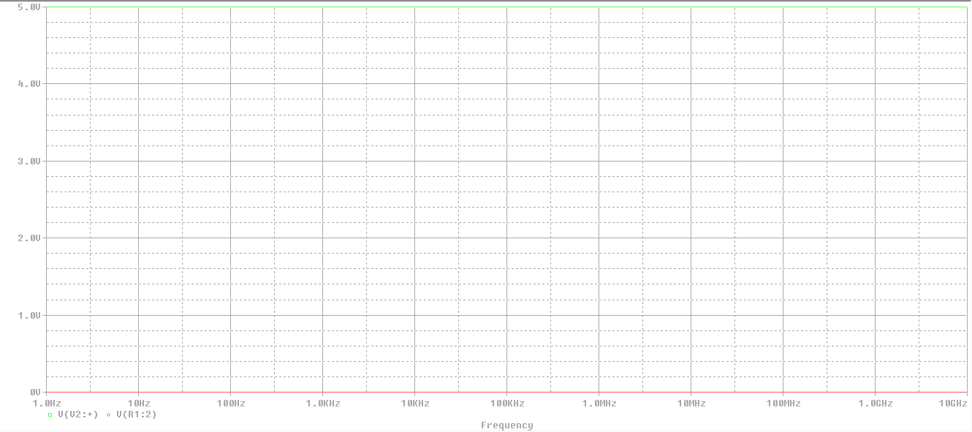Output (Cjo = 1e-20F)

No effect of frequency.

Comment:

Here with the high Cjo, there is no effect of frequency at all which means that the more of Cjo you increase, the later the frequency effect appears.

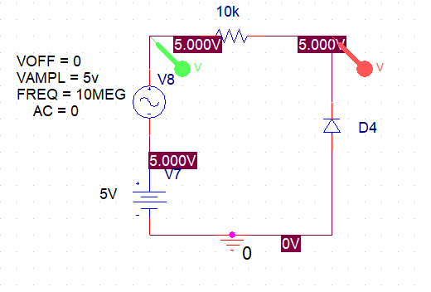1- Second circuit, output is diode (Transient Analysis)

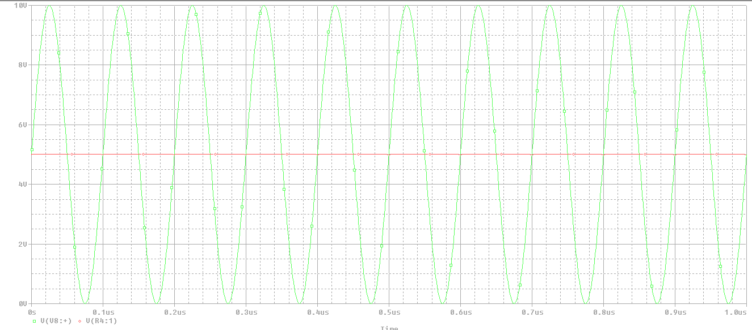Output (Cjo = 15nF)

Comment:

There is no output voltage on the diode. It behaves as an open circuit.

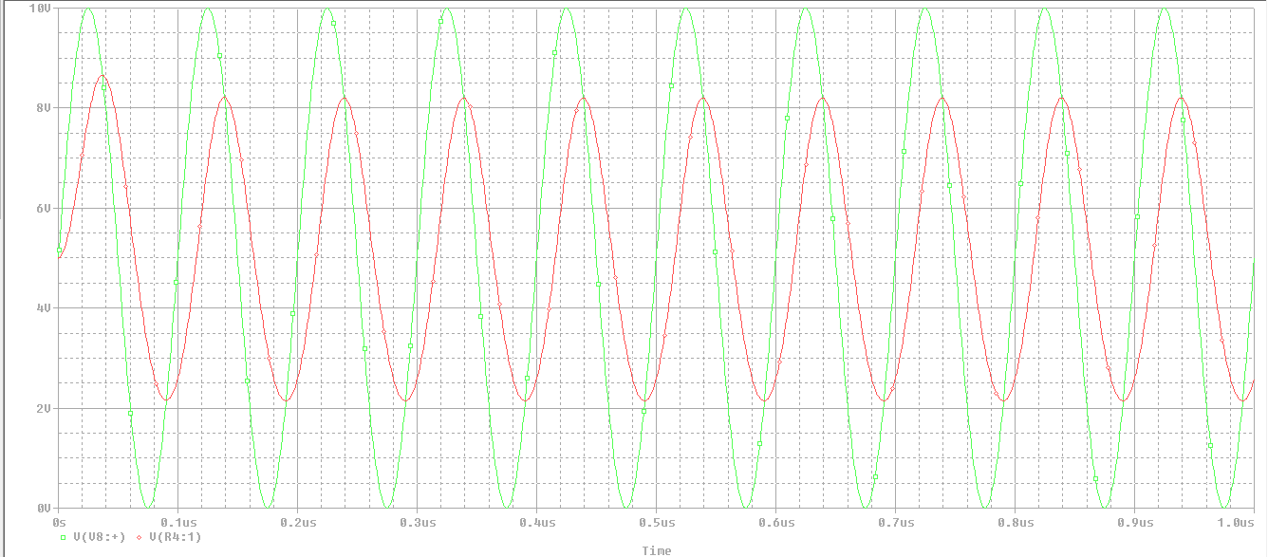Output (Cjo = 5pF)

*Note that the output starts to come out but shifted to the right*

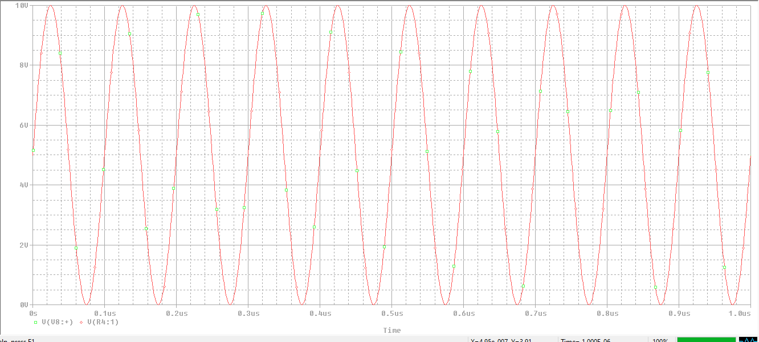Output (Cjo = 1e-20F)

Comment:

When we increase the Cjo of the diode it starts to act as a short circuit and holds all the voltage of input.

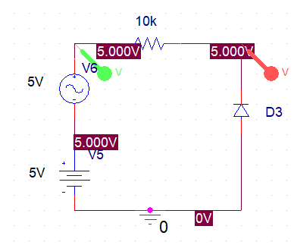1- Second circuit (AC sweep)

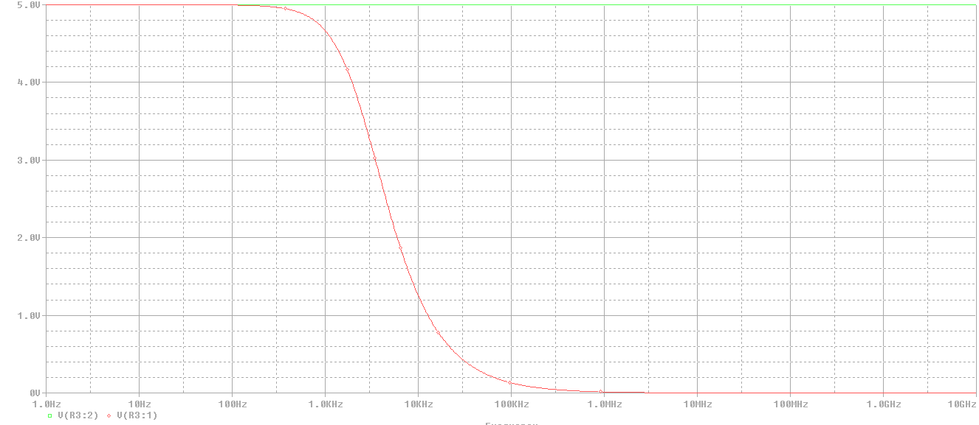Output (Cjo = 15nF)

*Note that the range of frequency effect is 100Hz – 500KHz*

Comment:

In the second circuit, the opposite is happening, so in this case, our circuit acts as low pass filter.

Output (Cjo = 5pF)

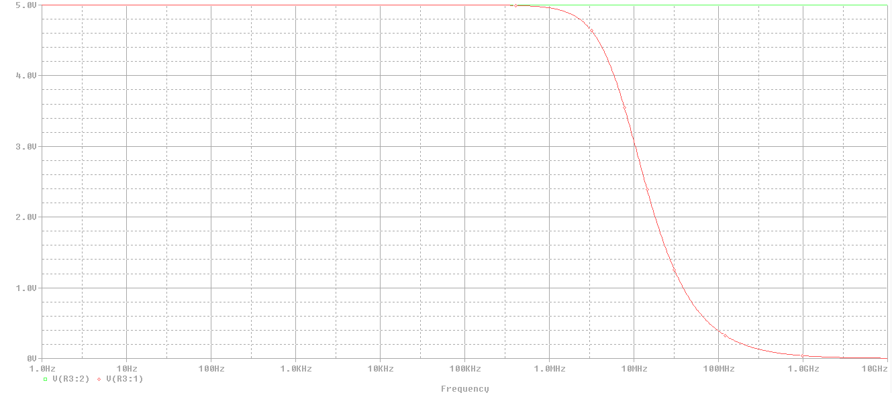

*Note that the range became 1MHz to 500MHz*

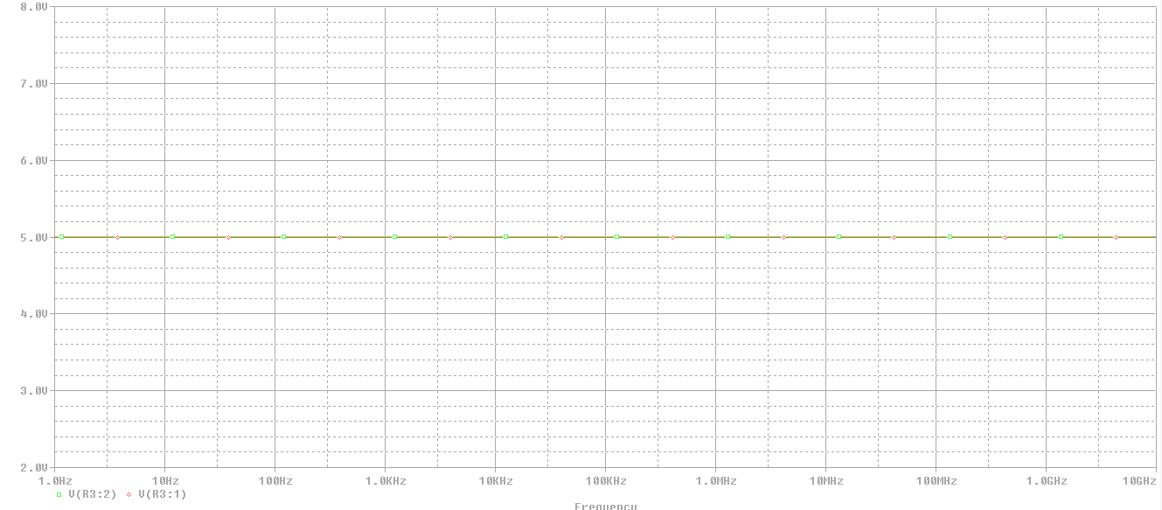Output (Cjo = 1e-20F)

Comment:

As we highly increased the Cjo, the effect of frequency disappears, and the diode behaved as open circuit. So that the diode output holds the same value of input voltage all over the frequencies.

1- First circuit, output is resistance (Transient Analysis)



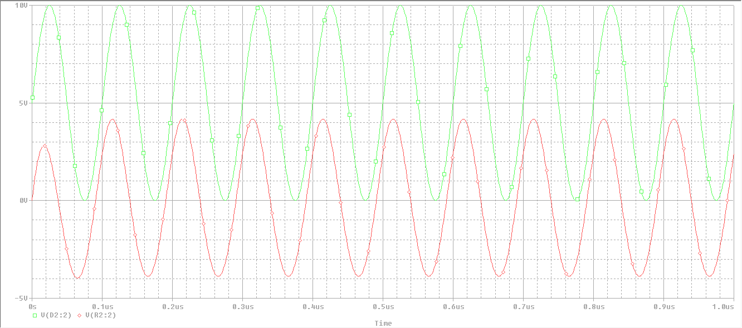Output (Cjo = 5pF, M = 0.42, VJ = 0.75V)

Comment:

Note that here we have the same output as before even after including the new parameters

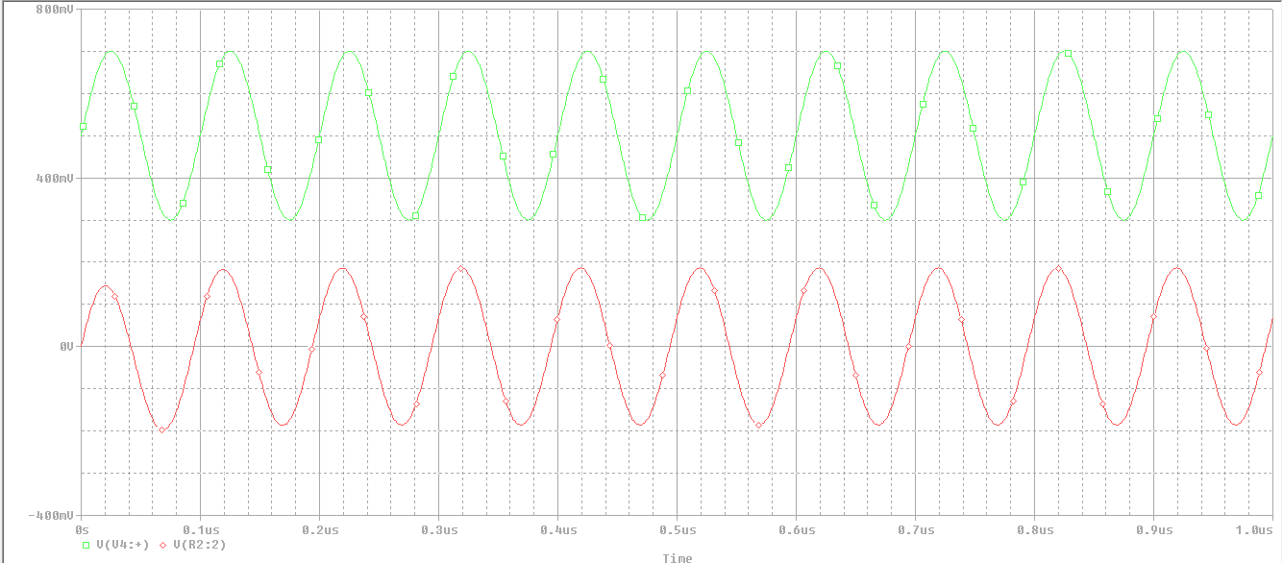Output (Vsin = 0.2V, VDC = 0.5V)

Note that the output voltage is alternating between roughly 0.2V and -0.2V

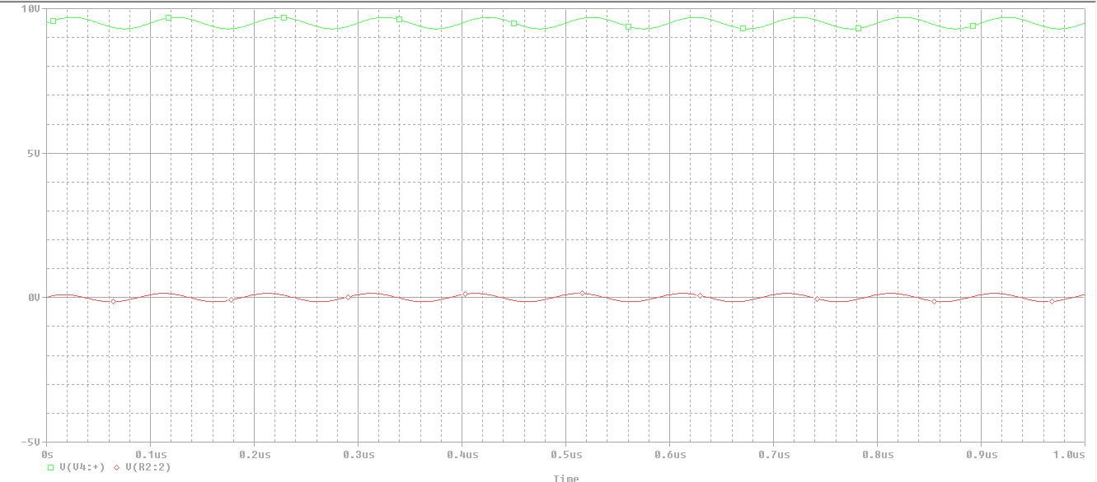Output (Vsin = 0.2V, VDC = 9.5V)

Comments:

Now, we could see the ripples on the output voltage. Since the voltage of diode which increased affects the junction capacitor of the diode with reversely relation

**The same steps but in the AC Sweep:**

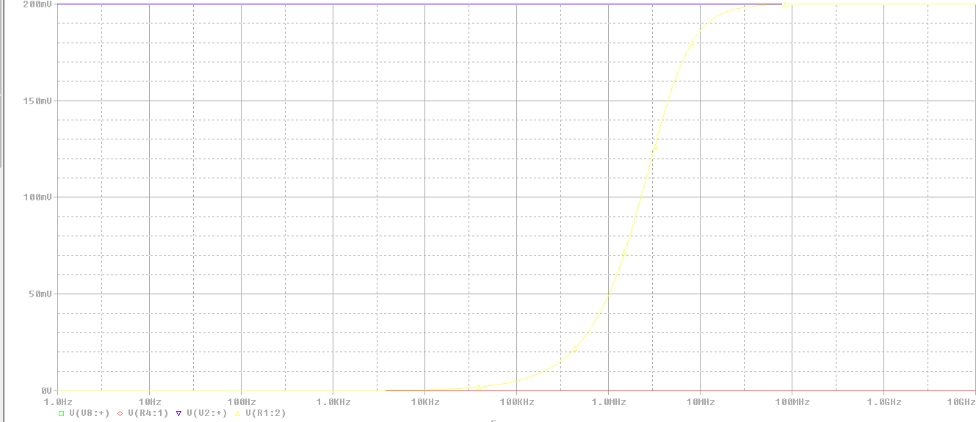Output (VAC = 0.2V, VDC=0.5V)

Note where the output starts to saturate in terms of frequency at roughly 100MHz

Output (VAC = 0.2V, VDC=9.5V)

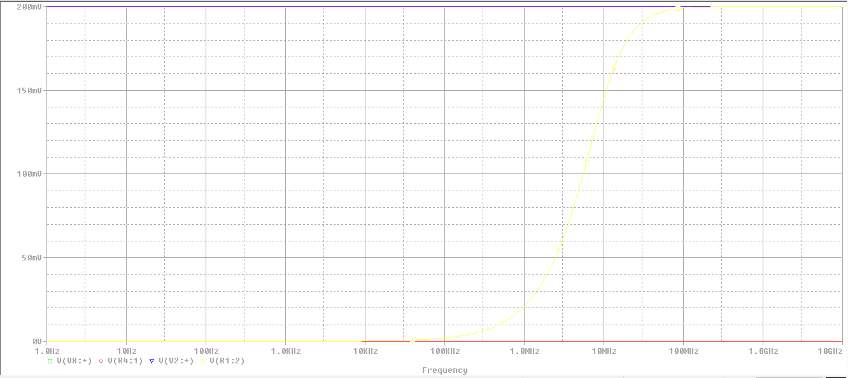

If you zoomed in the plot, you would find that it saturates at 300MHz

Comment:

So, when the VDC increased, the range of frequencies will be affected and so on.

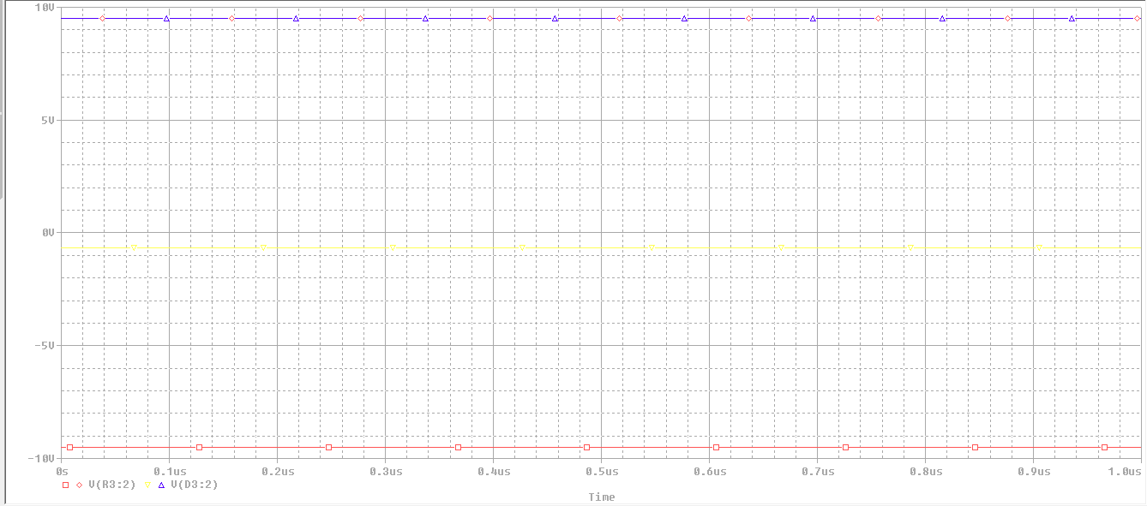1- Second circuit, output is diode (parametric sweep)

After the DC sweep:

